EDGEENHANCHING DIGITAL GOVERNMENT AND ECONOMY



Enhancing Digital Government & Economy (EDGE) Project

Bangladesh Computer Council Information and Communication Technology Division Ministry of Posts, Telecommunications and Information Technology Government of the People’s Republic of Bangladesh

And

Center for Digital Transformation (CDT)

Begum Rokeya University, Rangpur

Rangpur-5404, Bangladesh

**Digital Skills for Students**

#### **Project Title: The July Revolution 2024: A Defining Moment in Bangladesh’s Political Transformation**

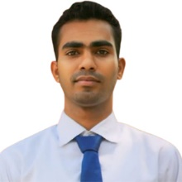**Name :** Jillur Rahman

**Department :** History &Archaeology

**Session :** 2023-2024

**Serial** : s-24

**Batch :** 27

**Year :** M. A 1st year ,1st semester

Signature

Date:16-01-2025

**The July Revolution 2024: A Defining Moment in Bangladesh’s Political Transformation**

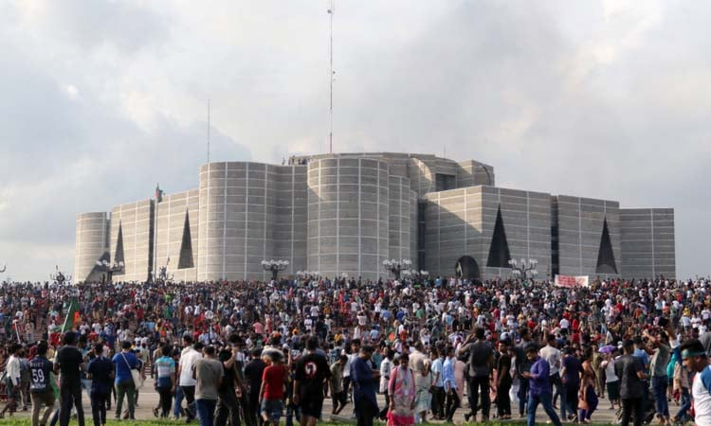

Executive Summary

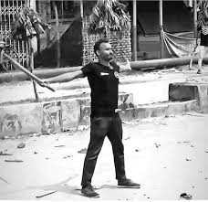The July Revolution 2024 in Bangladesh marked a turning point in the nation's history, redefining its political, social, and economic framework. This project explores the causes, major events, and impacts of this revolution, offering insights into its significance and lessons for governance, democracy, and civil society.

Introduction

The political, economic, and social climate in Bangladesh in the early 2020s was marked by rising public dissatisfaction. Governance challenges, economic disparities, and political centralization fueled unrest among the population. The July Revolution 2024 emerged as a response to these systemic issues, leading to nationwide mobilization and calls for transformative reforms.

Objectives of the Study:

* To identify the causes of the July Revolution 2024.
* To analyze the key events and stakeholders involved.
* To evaluate the short- and long-term impacts of the revolution.

**Background and Context**

Political and Economic Landscape Pre-2024

* Persistent allegations of corruption and erosion of democratic norms.
* Economic challenges, including inflation, unemployment, and widening income inequality.
* Limited representation of youth and marginalized communities in governance structures.

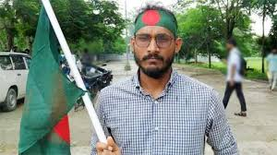

Abu Sayeed Islam

Social Dynamics

* Increased activism among the younger population, driven by frustration with the status quo.
* The role of digital media in amplifying public grievances and organizing protests.

Causes of the Revolution

1. Economic Disparities:

* + Rising inflation and a declining standard of living.
  + Youth unemployment and dissatisfaction with job opportunities.

2. Political Discontent:

* + Allegations of electoral malpractice and lack of transparency in governance.
  + Public outcry against political repression and lack of accountability.

3. Socio-Cultural Catalysts:

* + Mobilization through social media and grassroots movements.
  + Growing demand for justice, equality, and democratic reforms.

Trigger Incident

The revolution was ignited by [describe the specific event, e.g., a controversial decision or public confrontation], which became a rallying point for public anger.

Phases of the Revolution

1. Initial Protests:

* + Small-scale demonstrations organized by students, activists, and opposition groups.

2. Nationwide Mobilization:

* + Mass participation from diverse sections of society, including urban and rural populations.

3. Resolution and Outcomes:

* Resignation or reform efforts by key government figures.
* Introduction of new policies addressing public demands.

**Key Figures and Stakeholders**

1. Leaders of the Movement:

* + Profiles of prominent activists, political figures, and community leaders who spearheaded the revolution.

2. Role of Civil Society:

* Contribution of NGOs, media outlets, and social organizations in mobilizing support.

3. **Government Response:**

* + The state’s approach, including dialogue, suppression, or policy reforms.

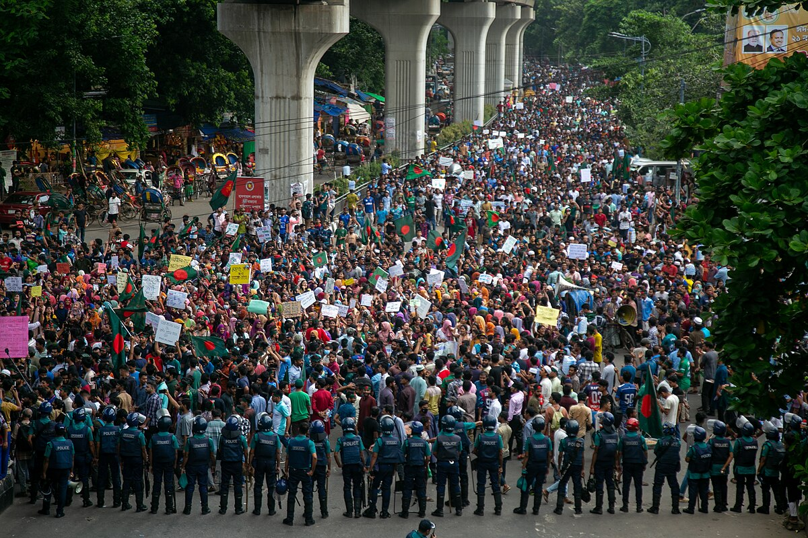

### Bangla Blockade and Chhatra League attacks (10–17 July)

**10 July**

At approximately 11:00 a.m. in the [University of Dhaka](https://en.wikipedia.org/wiki/University_of_Dhaka), a protest march commenced in front of the library, passed by the [Raju Memorial Sculpture](https://en.wikipedia.org/wiki/Anti_Terrorism_Raju_Memorial_Sculpture), and culminated in the blockage of the [Shahbagh](https://en.wikipedia.org/wiki/Shahbagh" \o "Shahbagh) intersection. Members of the law and order forces positioned barricades in front of the students. In the afternoon, it is known that the status quo has been given for four weeks in the ruling given by the High Court canceling the quota system. The Chief Justice asked the students to go back. Dhaka's transport system came to a standstill due to the blockade in various parts of Dhaka. Long-distance buses and trains were stopped due to the agitation.

Police attacked protesting students of [Comilla University](https://en.wikipedia.org/wiki/Comilla_University).

#### 11 July

The blockade in [Shahbagh](https://en.wikipedia.org/wiki/Shahbagh" \o "Shahbagh) was supposed to start at 03:00 p.m. but due to rain, the students crossed the police barricade on their way to Shahbagh and started later at 04:30 p.m. Dhaka College students retreated due to police barricades and Dhaka University students joined the students of [Jagannath University](https://en.wikipedia.org/wiki/Jagannath_University) at Shahbagh. Apart from Shahbagh, other places in Dhaka were unaffected by the movement. At 09:00 p.m., the students ended their agitation and announced a protest march and rally on 12 July to protest the violent police attack on them.

12July

At 05:00 p.m., students gathered at Shahbagh and staged a blockade in the area.

While students were protesting at Comilla Victoria College, a group of Chhatra League members launched an attack on the protesters. During the situation, a student who was recording a video was taken to a hall and beaten by the Chhatra League members

#### 13 July

Students protested by blocking the railway tracks in Rajshahi.[[143]](https://en.wikipedia.org/wiki/2024_Bangladesh_quota_reform_movement#cite_note-154) In Dhaka, DU students held a press conference in the evening, where they complained that attempts were being made to block the students' movement with lawsuits.

#### 14 July

Students marched in Dhaka and held a sit-in protest and blockade, later submitting a memorandum to [President](https://en.wikipedia.org/wiki/President_of_Bangladesh) [Mohammed Sahabuddin](https://en.wikipedia.org/wiki/Mohammed_Shahabuddin).

In response to the controversial statement made by the Prime Minister of Bangladesh during a press conference, where she reportedly referred to students protesting the quota reform movement as the children of [Razakars](https://en.wikipedia.org/wiki/Razakar_(Pakistan)" \o "Razakar (Pakistan)) (traitors in the [1971 Independence War](https://en.wikipedia.org/wiki/Bangladesh_Liberation_War)), students organized a midnight demonstration at the Dhaka University campus area *(See the*[*§ Razakar remarks*](https://en.wikipedia.org/wiki/2024_Bangladesh_quota_reform_movement#Razakar_remarks)*section)*. Female students from Rokeya Hall joined the protest by breaking the lock put up by the authorities at the dorm gate.

The government instructed operators to shut down the 4G network in the [University of Dhaka](https://en.wikipedia.org/wiki/University_of_Dhaka) area.[[147]](https://en.wikipedia.org/wiki/2024_Bangladesh_quota_reform_movement#cite_note-158) At around 11:30 p.m., leaders and members of the [Bangladesh Chhatra League](https://en.wikipedia.org/wiki/Bangladesh_Chhatra_League) attacked protesters at the [University of Chittagong](https://en.wikipedia.org/wiki/University_of_Chittagong) injuring 13 protesters.

15 July

The attacks against the protesters began soon after the ruling Awami League general secretary said on Monday that the Bangladesh Chhatra League, the student wing of the ruling party, was ready to give a fitting reply to quota protesters for their 'arrogant behaviour

In [Jessore](https://en.wikipedia.org/wiki/Jessore) at around 12:00 p.m., students from [Jessore University of Science and Technology](https://en.wikipedia.org/wiki/Jessore_University_of_Science_and_Technology) and [Michael Madhusudan College](https://en.wikipedia.org/wiki/Michael_Madhusudan_College) staged a protest, where a member of the [Chhatra League](https://en.wikipedia.org/wiki/Bangladesh_Chhatra_League) attacked and injured a protester.

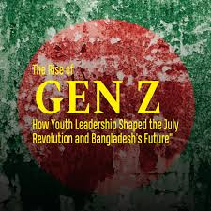In Dhaka, Members of the Chhatra League started their procession to Shahbagh from [Segunbagicha](https://en.wikipedia.org/wiki/Segunbagicha" \o "Segunbagicha) near [Motsho Bhobon](https://en.wikipedia.org/wiki/Department_of_Fisheries_(Bangladesh)" \o "Department of Fisheries (Bangladesh)) at around 03:45 p.m.

Later in the evening, Chhatra League members attacked students inside [Bijoy Ekattor Hall](https://en.wikipedia.org/wiki/University_of_Dhaka#Residential_halls_and_hostels) of Dhaka University, where some of the attackers were seen shooting with [pistols](https://en.wikipedia.org/wiki/Pistols) and [carrying sticks](https://en.wikipedia.org/wiki/Stick-fighting). In response, the protesters also threw brickbats from the inside of the hall to retaliate. While covering the protest in the University of Dhaka, two journalists from [*The Daily Star*](https://en.wikipedia.org/wiki/The_Daily_Star_(Bangladesh)) and [*Prothom Alo*](https://en.wikipedia.org/wiki/Prothom_Alo) were assaulted and injured in the attack carried out by the Chhatra League.

At 5:30 p.m., members of the Chhatra League attempted to attack the emergency department of [Dhaka Medical College Hospital](https://en.wikipedia.org/wiki/Dhaka_Medical_College_Hospital), where over 200 students injured in the clashes were seeking treatment. After several attempts throughout the afternoon, Chhatra League members, some wearing helmets, forcibly entered DMCH around 7:30 p.m. and initiated an attack. Many were observed carrying rods. They targeted students already injured in the quota reform movement and vandalized several ambulances parked at DMCH.

Later the same evening, an attack carried out by the Chhatra League Rajshahi branch at [Rajshahi University](https://en.wikipedia.org/wiki/Rajshahi_University" \o "Rajshahi University) left six students injured, including the joint convenor of the [Bangladesh Students Union](https://en.wikipedia.org/wiki/Bangladesh_Students_Union) at RU.

In [Comilla](https://en.wikipedia.org/wiki/Comilla), The [CoU](https://en.wikipedia.org/wiki/University_of_Comilla" \o "University of Comilla) coordinator of the anti-discrimination student movement was assaulted at around 8:00 p.m. when eight Chhatra League members called him to check his phone and beat him.

The protesters called for nationwide demonstrations and rallies in all educational institutions of the country at 03:00 p.m. on 16 July.

#### **16 July**

At around 12:15 a.m., members of the Chhatra League attacked [Jahangirnagar University](https://en.wikipedia.org/wiki/Jahangirnagar_University) students using firearms. The students took shelter at the vice-chancellor's residence after breaking its lock. Around 300 Chhatra League members, armed with galvanized pipes and sticks, threw bricks and glass bottles at the students. Shots were reportedly fired, injuring two journalists, including one from [*Dhaka Tribune*](https://en.wikipedia.org/wiki/Dhaka_Tribune) and over 50 student protesters.

Police arrived to control the situation, while both groups positioned themselves outside the vice-chancellor's residence. Students claimed the attacker’s included outsiders, some in their forties. Later on, the sub-inspector of the Ashulia Police Department instead decided to blame the students by stating that the protesters are to blame for causing "this mayhem".

A violent incident involving police and students demanding quota reforms took place in front of [Begum Rokeya University](https://en.wikipedia.org/wiki/Begum_Rokeya_University,_Rangpur) in [Rangpur](https://en.wikipedia.org/wiki/Rangpur,_Bangladesh) between 2:30 p.m. and 3:00 p.m. Police resorted to [lathi charges](https://en.wikipedia.org/wiki/Lathi_charge) and firing during the incident. [Abu Sayed](https://en.wikipedia.org/wiki/Abu_Sayed_(student_activist)), a Begum Rokeya University student and quota reform activist, was shot four times by a police officer. He was taken to [Rangapur Medical College Hospital](https://en.wikipedia.org/wiki/Rangpur_Medical_College" \o "Rangpur Medical College) where the doctors pronounced him [dead on arrival](https://en.wikipedia.org/wiki/Dead_on_arrival).

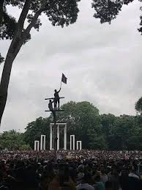At around 3:30 p.m., it was reported that in the [Farmgate–Khamarbari area](https://en.wikipedia.org/wiki/Farmgate), Chhatra League assailants attacked protestors with sticks while students from [Govt. Science College](https://en.wikipedia.org/wiki/Government_Science_College,_Dhaka) were protesting against the attack of Chatra Leage in University of Dhaka. When the protestors took shelter in the [Farmgate metro station](https://en.wikipedia.org/wiki/Farmgate_metro_station), the assailants entered and started to beat the students, which was witnessed by the passengers. Police were allegedly deployed to control the situation. However, DMTCL, the authority responsible for the operation for the [Dhaka Metro Rail](https://en.wikipedia.org/wiki/Dhaka_Metro_Rail), denied these claims and stated that guards of the station drove the "miscreants" away as they entered with bamboo sticks. They also stated that there was no damage to the station. However, they announced plans to close some of the gates of the station complex for some time to prevent the recurrence of such incidents.

As students at public universities were forcefully vacated, students from various schools, colleges, and private universities joined the cause. They protested and blocked roads against the violence of the Chhatra League in the quota reform movement, including [Notre Dame College](https://en.wikipedia.org/wiki/Notre_Dame_College,_Dhaka), [Dhaka Residential Model College](https://en.wikipedia.org/wiki/Dhaka_Residential_Model_College), [RAJUK Uttara Model College](https://en.wikipedia.org/wiki/RAJUK_Uttara_Model_College), [Adamjee Cantonment College](https://en.wikipedia.org/wiki/Adamjee_Cantonment_College), [Viqarunnisa Noon School and College](https://en.wikipedia.org/wiki/Viqarunnisa_Noon_School_and_College" \o "Viqarunnisa Noon School and College),[Govt. Science College](https://en.wikipedia.org/wiki/Government_Science_College,_Dhaka),[Ideal School and College](https://en.wikipedia.org/wiki/Ideal_School_and_College), [Ideal College](https://en.wikipedia.org/wiki/Ideal_College), [Dhaka City College](https://en.wikipedia.org/wiki/Dhaka_City_College), [BAF Shaheen College Dhaka](https://en.wikipedia.org/wiki/BAF_Shaheen_College_Dhaka), [BAF Shaheen College Kurmitola](https://en.wikipedia.org/wiki/BAF_Shaheen_College_Kurmitola), [Birshrestha Noor Mohammad Public College](https://en.wikipedia.org/wiki/Birshrestha_Noor_Mohammad_Public_College" \o "Birshrestha Noor Mohammad Public College), [Birshrestha Munshi Abdur Rauf Public College](https://en.wikipedia.org/w/index.php?title=Birshreshtha_Munshi_Abdur_Rauf_Public_College&action=edit&redlink=1" \o "Birshreshtha Munshi Abdur Rauf Public College (page does not exist)) and so on.

Students of [North South University](https://en.wikipedia.org/wiki/North_South_University), [Independent University Bangladesh](https://en.wikipedia.org/wiki/Independent_University_Bangladesh), [United International University](https://en.wikipedia.org/wiki/United_International_University) and [BRAC University](https://en.wikipedia.org/wiki/BRAC_University) protested at and around their respective premises areas at [Bashundhara Residential Area](https://en.wikipedia.org/wiki/Bashundhara_Residential_Area) and [Merul Badda](https://en.wikipedia.org/wiki/Badda_Thana" \o "Badda Thana) with the blockade set up by the students extending up to [Baridhara](https://en.wikipedia.org/wiki/Baridhara), the [Pragati Sarani Streets](https://en.wikipedia.org/wiki/Pragati_Sarani) in front of the [Jamuna Future Park](https://en.wikipedia.org/wiki/Jamuna_Future_Park) mall, the largest mall in the country, Notun Bazar, [Badda](https://en.wikipedia.org/wiki/Badda_Thana" \o "Badda Thana), and [Kuril](https://en.wikipedia.org/wiki/Kuril_Flyover), causing gridlock to its neighboring areas as well, including [Rampura](https://en.wikipedia.org/wiki/Rampura_Thana), [Banasree](https://en.wikipedia.org/wiki/Banasree), Badda Link Road and Abul Hotel area in [Malibagh](https://en.wikipedia.org/wiki/Malibagh" \o "Malibagh). During this time, Asif Mahtab Utsha, former lecturer of [Brac University](https://en.wikipedia.org/wiki/Brac_University), notable for [the textbook tearing controversy](https://en.wikipedia.org/wiki/2024_Bangladesh_textbook_tearing_controversy), joined with his students in front of Jamuna Future Park, being the first teacher in Bangladesh to do so. He gave a speech in the open and in front of national media where he rebuked his colleagues for not joining the students and being their shield, while also challenging the [Chaatra League](https://en.wikipedia.org/wiki/Bangladesh_Chhatra_League" \o "Bangladesh Chhatra League) criminals who attacked Dhaka University students to come to Bashundhara Gate. In his speech he attempted to boost morale of the students by saying, "I did not teach my students to fall back. No retreat, only forward"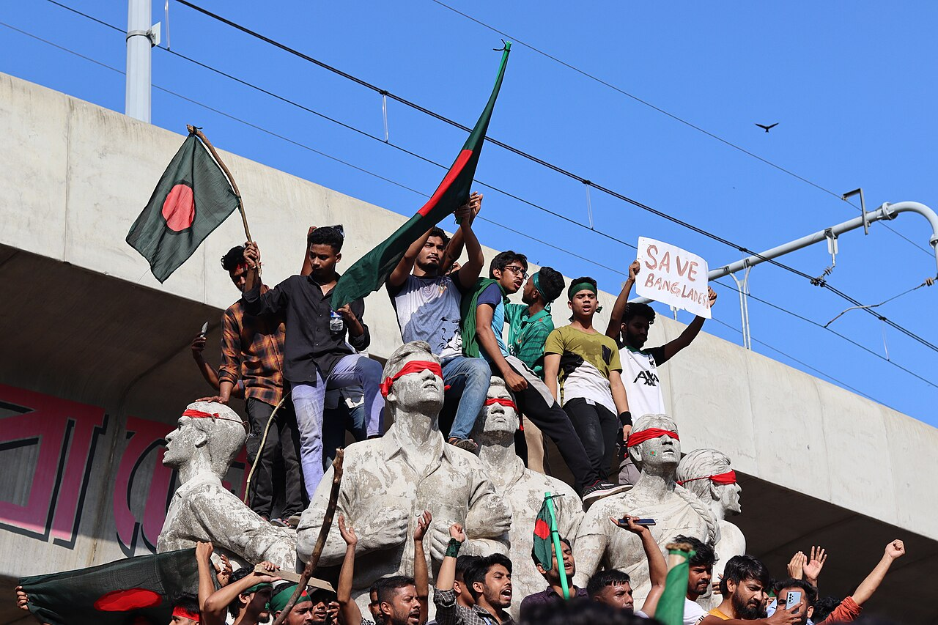.

Students of [University of Scholars](https://en.wikipedia.org/wiki/The_International_University_of_Scholars), [Primeasia University](https://en.wikipedia.org/wiki/Primeasia_University" \o "Primeasia University) and [Far East University](https://en.wikipedia.org/wiki/Fareast_International_University) blocked the [Banani](https://en.wikipedia.org/wiki/Banani_(neighbourhood)) area and [New Airport road](https://en.wikipedia.org/wiki/Airport_Road,_Dhaka). Students of [Notre Dame College](https://en.wikipedia.org/wiki/Notre_Dame_College,_Dhaka) protested in the country's main financial hub and the largest central business district of [Motijheel](https://en.wikipedia.org/wiki/Motijheel_Thana" \o "Motijheel Thana) at [Shapla Square](https://en.wikipedia.org/wiki/Shapla_Square" \o "Shapla Square). Students of [Daffodil International University](https://en.wikipedia.org/wiki/Daffodil_International_University) also attempted to start a demonstration on the road but instead protested on campus. Students of other universities and colleges also joined the protests. Protests also took place in [Dhanmondi](https://en.wikipedia.org/wiki/Dhanmondi_Thana), specifically in front of the Science Laboratory area and in [Uttara](https://en.wikipedia.org/wiki/Uttara_(neighbourhood)). Gridlocks were also experienced at places like [Mohammadpur](https://en.wikipedia.org/wiki/Mohammadpur_Thana), [Dhanmondi](https://en.wikipedia.org/wiki/Dhanmondi_Thana), [Mirpur Road](https://en.wikipedia.org/wiki/Mirpur_Road), and Gabtoli.

Students blocked railway lines in [Chattogram](https://en.wikipedia.org/wiki/Chattogram) and [Mohakhali](https://en.wikipedia.org/wiki/Mohakhali). The [Dhaka–Chattogram](https://en.wikipedia.org/wiki/N1_(Bangladesh)), [Dhaka–Barisal](https://en.wikipedia.org/wiki/N8_(Bangladesh)), Dhaka–Rajshahiand [Dhaka–Tangail](https://en.wikipedia.org/wiki/N4_(Bangladesh)) [highways](https://en.wikipedia.org/wiki/Highway) were also blocked. In the evening, the [Ministry of Education](https://en.wikipedia.org/wiki/Ministry_of_Education_(Bangladesh)) announced the indefinite closure of schools and colleges and the postponing of the [HSC exam](https://en.wikipedia.org/wiki/Higher_Secondary_Certificate#Bangladesh) scheduled for 18 July. The [UGC](https://en.wikipedia.org/wiki/University_Grants_Commission_(Bangladesh)) declared that all public and private universities across the country will remain closed until further notice. At the same time, all affiliated medical, textile, engineering and other colleges will also remain closed. The commission also directed university authorities to vacate residential halls allegedly considering safety of the students.

In remembrance of the fallen, the movement announced a symbolic funeral prayer scheduled for July 17.

Impact of the Revolution

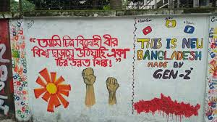**Political Impact:**

* + Restructuring of governance and leadership changes.
  + Strengthened democratic institutions and accountability mechanisms.

**Economic and Social Impact:**

* Immediate economic disruptions versus long-term policy reforms.
* Greater civic engagement and youth participation in politics.

**Global and Regional Implications:**

* + Bangladesh’s enhanced role as an example of people-powered change in south Asia.

**Lessons Learned**

* + The importance of addressing systemic grievances before they escalate into crises.
  + The role of youth and civil society as catalysts for democratic change.
  + The need for transparent governance and inclusive development to maintain stability.

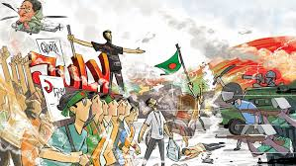July - Auguest Revolution in 2024 of Bangladesh Heart Touching Moments

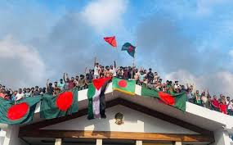**Conclusion**

The July Revolution 2024 was a pivotal event that demonstrated the power of collective action in challenging entrenched systems. It underscored the importance of responsive governance and the need for long-term reforms to address public grievances. This revolution has left a lasting impact on Bangladesh’s political and social landscape, shaping its trajectory toward a more equitable and democratic future.

**References**

* Academic journals and books on Bangladesh’s political history.
* Reports from reputable news agencies documenting the events of July 2024.
* Testimonies from eyewitnesses, activists, and analysts.
* Government documents and policy announcements.

THE END